IMPLEMENT BOOSTING TECHNIQUE (ADABOOST) AND ANALYZE PERFORMANCE

AIM
To implement the AdaBoost Classification algorithm in Python to predict student results based on hours studied, attendance, and assignments, and evaluate the model's performance using accuracy, confusion matrix, classification report, and a feature importance graph.

ALGORITHM:
1. Import the required libraries: Pandas, Matplotlib, and Scikit-learn.
2. Load the dataset from `data.csv`.
3. Select `Hours_Studied`, `Attendance`, and `Assignments` as input features.
4. Select `Result` as the target variable.
5. Split the dataset into training and testing sets using an 80:20 ratio.
6. Create an AdaBoost Classifier with 50 estimators.
7. Train the model using the training dataset.
8. Predict student results using the testing dataset.
9. Calculate the model's accuracy.
10. Display the confusion matrix and classification report.
11. Extract the feature importance values from the trained model.
12. Plot a bar graph showing the importance of each feature.

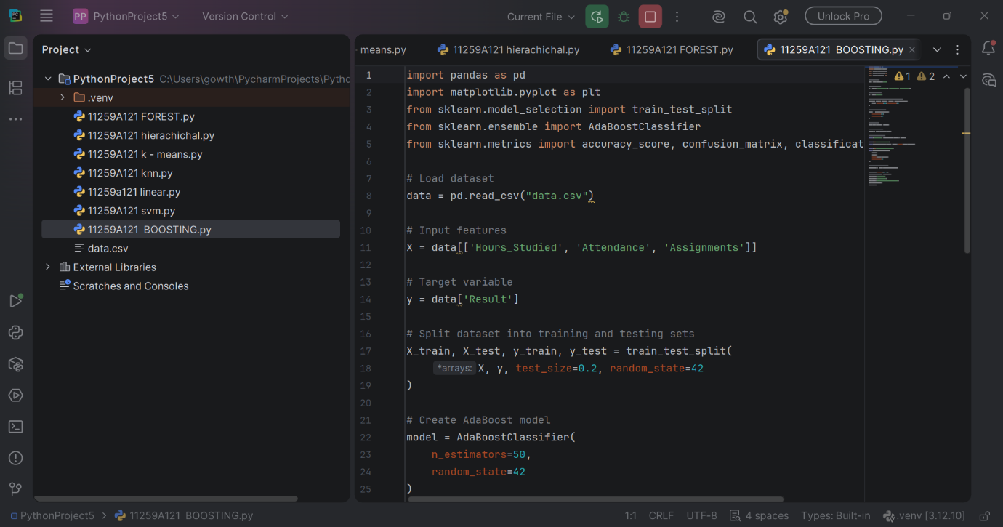
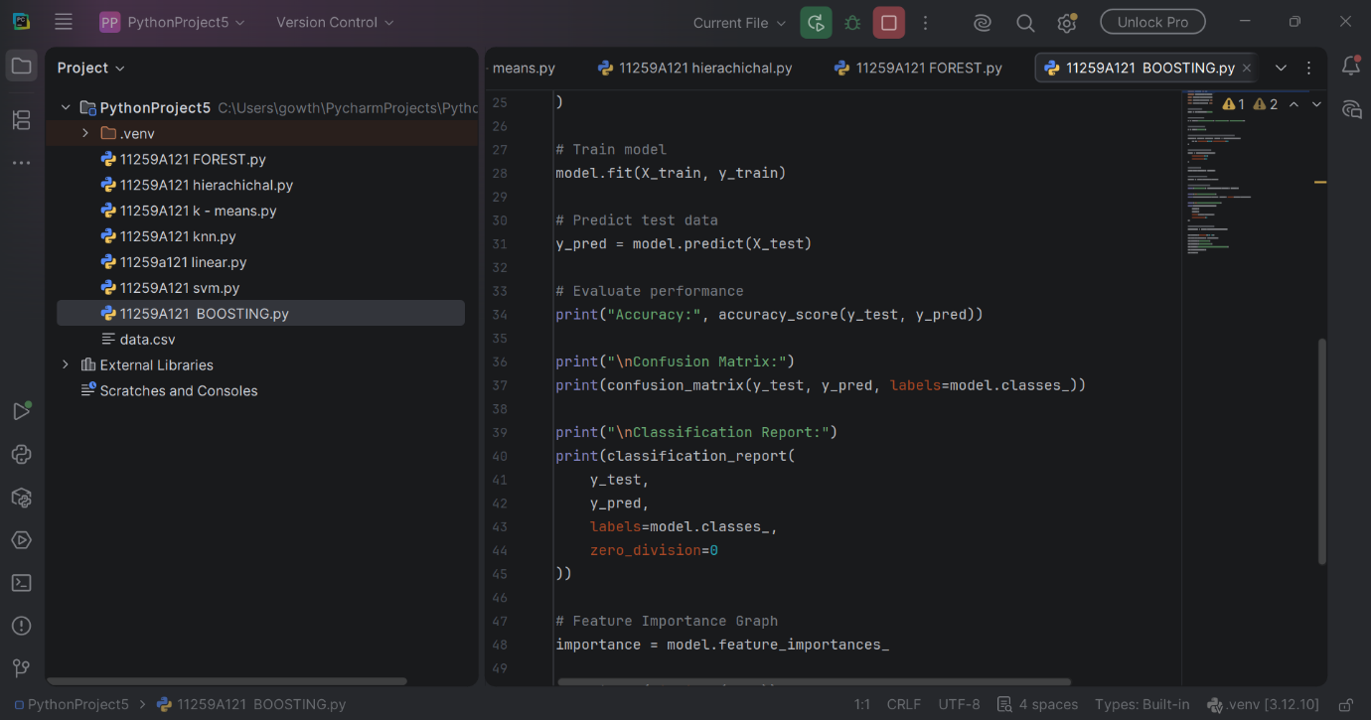
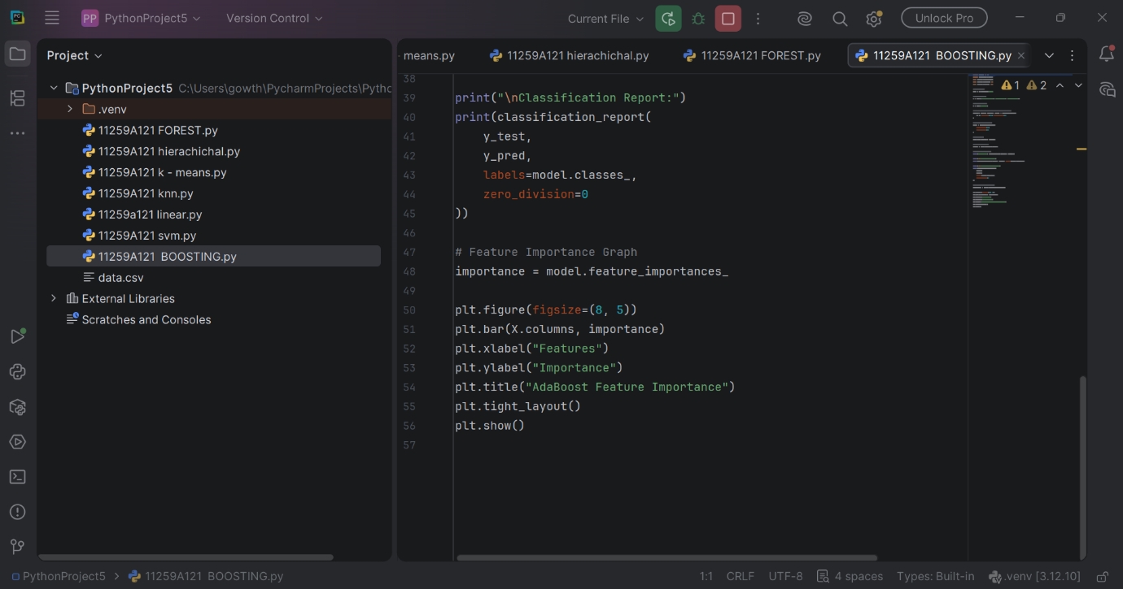
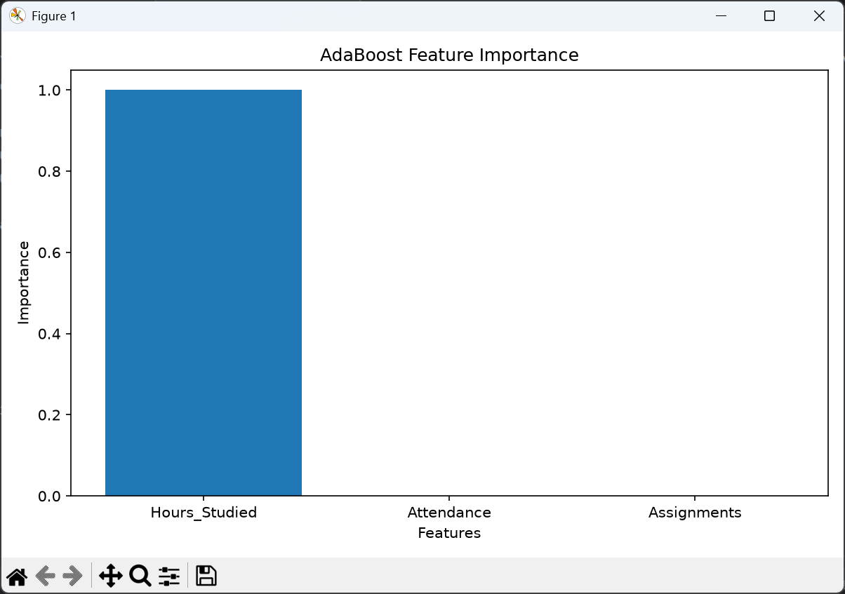
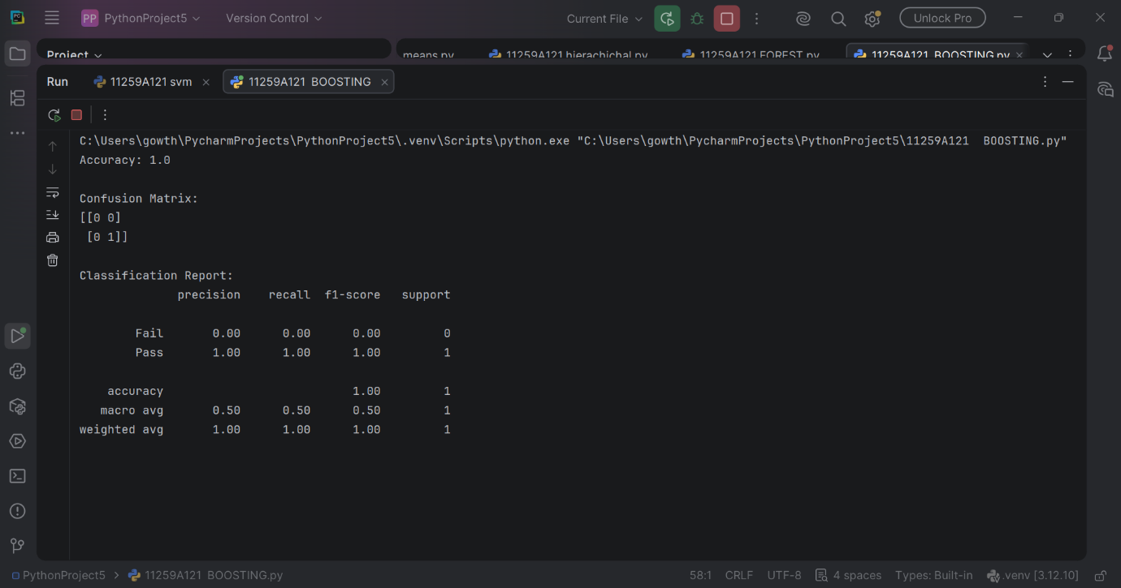

RESULT
Thus, the AdaBoost Classification algorithm was successfully implemented in Python to predict student results. The model's performance was evaluated using accuracy, confusion matrix, and classification report, and the feature importance graph was displayed successfully.

